AlienBreed Game References:

<https://www.thingiverse.com/thing:2491698>

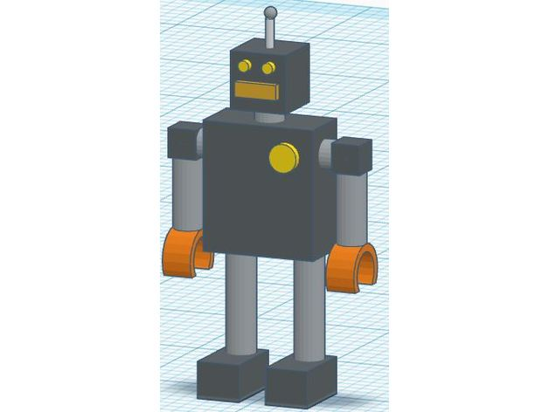

<https://depositphotos.com/333293412/stock-photo-seamless-scifi-panels-futuristic-texture.html>

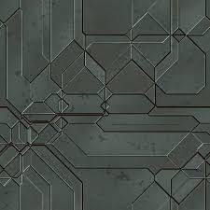

<http://www.psd-dude.com/tutorials/resources/metal-and-metallic-textures-for-photoshop.aspx>

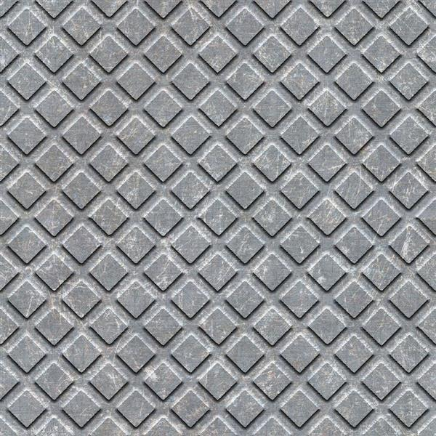

<http://free-texture-site.blogspot.com/2010/10/free-wooden-crate-texture.html>

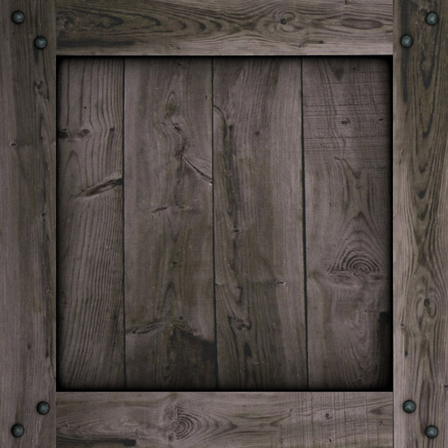

<http://4eyes.code66.se/?p=5116>

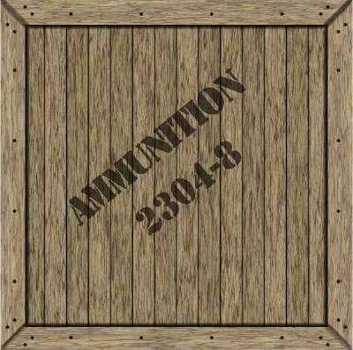

<https://www.123rf.com/photo_47960920_dark-wall-texture-seamless-background-decorative-plaster-.html>

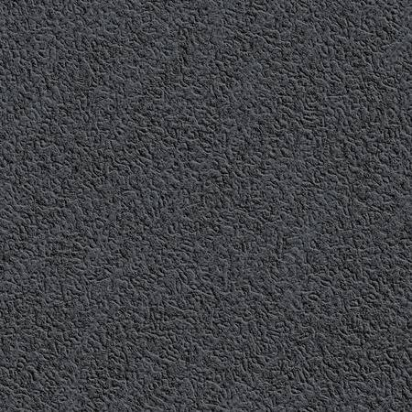

<https://stockfresh.com/image/1918150/seamless-texture-of-dirty-concrete-wall>

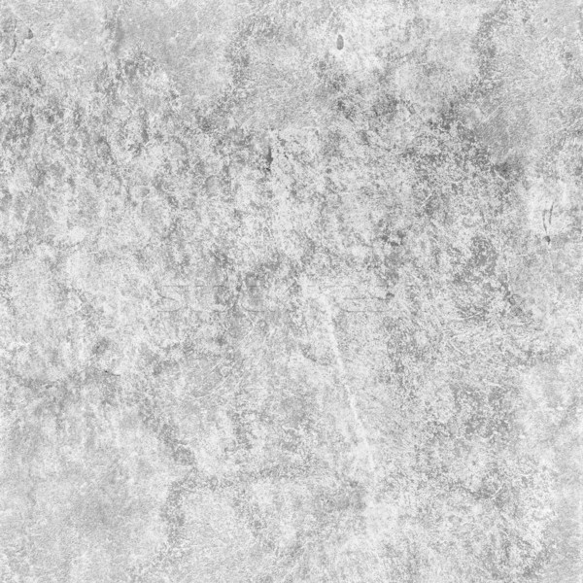

<https://www.pinterest.co.uk/pin/367043438380753233/>

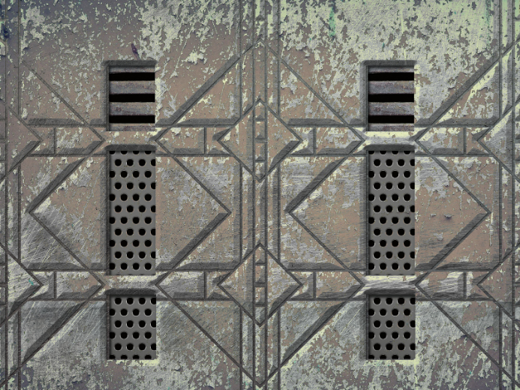

<https://www.myfreetextures.com/framed-brushed-metal-background-texture/>

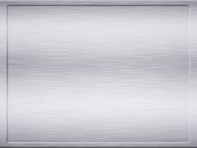

<http://soundbible.com/874-Walking-Away.html>

walking audio

<http://soundbible.com/2213-Alien-Spaceship-UFO.html>

Ambience